UDC 334.75

**CONSUMER SEGMENTATION USING CLUSTER ANALYSIS TOOLS TO STUDY THE UNDERCONSUMPTION CORE TREND**

**Geseleva N. V.** – Candidate of Technical Sciences, Assoc. Prof., Department of Digital Economy and System Analysis, State University of Trade and Economics, Kyiv, Ukraine.

**Shcherbyna Y. O.** – Undergraduate student of the Department of Information Technologies, State University of Trade and Economics, Kyiv, Ukraine.

**ABSTRACT**

**Context.** The fashion industry is increasingly shifting towards sustainability, with the second-hand clothing market playing a pivotal role in promoting circular fashion practices. The concept of the "underconsumption core" emphasizes mindful consumption, focusing on quality rather than quantity.

**Objective.** This study aims to analyze consumer behavior in the second-hand clothing industry. By utilizing cluster analysis methods, the research will identify distinct consumer segments based on their motivations and purchasing behaviors.

**Method.** A comprehensive framework is proposed to evaluate consumer behavior towards sustainable fashion, focusing on demographic and socio-economic factors. The approach employs cluster analysis to identify distinct segments within the dataset, utilizing k-means clustering as the primary technique. K-means was selected for its efficiency and effectiveness in partitioning data into meaningful clusters, allowing for easy interpretation of consumer profiles based on their purchasing behaviors. The clustering process begins by determining the optimal number of clusters, which is achieved through the Elbow method. This method is advantageous as it provides a clear visual representation of inertia metrics, facilitating informed decisions regarding the number of clusters to form while minimizing the potential for overfitting. The data preprocessing stage involves normalizing relevant features to ensure uniformity and comparability across different scales. This step is critical as it prevents any one variable from disproportionately influencing the clustering results. Following this, the k-means algorithm is executed, iteratively refining cluster centroids until convergence is achieved, thereby minimizing intra-cluster distances while maximizing inter-cluster distances. This iterative refinement ensures that the resulting clusters are robust and reflective of true consumer segments. Moreover, the method incorporates graphical visualizations to illustrate the distribution of responses across various demographic segments. These visual tools were selected for their ability to present complex data in an accessible format, enhancing interpretability.

**Results.** The developed indicators have been implemented in software and investigated for solving the problems of customer segmentation in sustainable fashion industry. The analysis resulted in distinct clusters that effectively differentiate the target audience, providing valuable insights into consumer behavior and preferences. These clusters reveal significant patterns related to age, occupation, and area of residence, allowing for targeted marketing strategies that align with the sustainability values of different consumer segments.

**Conclusions.** Modern business thrives by delivering highly personalized services to their customers, which would not have been possible without some form of customer segmentation. In doing so, organizations can easily structure their services and products around their customers while targeting them to drive more revenue. The conducted experiments have validated the functionality of the implemented software, demonstrating its effectiveness in addressing the challenges of customer segmentation in sustainable fashion. The findings support the recommendation of this software for practical use in diagnosing and automatically classifying consumer profiles based on specific features. Future research prospects include the development of parallel methods for calculating the proposed indicators, optimizing their software implementations, and conducting experimental studies to apply these indicators to more complex practical problems across various contexts and dimensions.

**KEYWORDS:** sustainability, consumer behavior, underconsumption core, cluster analysis, python, data visualization.

**NOMENCLATURE**

*d(x,μ)* is a Euclidean distance between an observation 𝑥 and its corresponding centroid 𝜇;

*x* is a specific observation (instance) in the dataset;

𝜇 is a centroid of a cluster, representing the mean position of all instances in that cluster;

*s* is the index for instances, where *s = 1, 2,…,S;*

*j* is the index for features, where *j = 1, 2,…,N;*

*N* is a total number of features characterizing the original sample;

*I* is an inertia, a metric that quantifies the coherence of the clusters by measuring the sum of squared distances between observations and their respective centroids;

*K* is a number of clusters formed during the segmentation process;

*Ck* is a set of instances belonging to cluster *k*;

𝜇*k* is a centroid of cluster *k*;

*x ∈ Ck* is an observation *x* that belongs to cluster *k*.

**INTRODUCTION**

The increasing popularity of second-hand clothing reflects a broader societal shift towards sustainability, mindful consumption, and the emerging trend of the underconsumption core in the fashion industry. This concept emphasizes the reduction of excess purchases in favor of fewer, more sustainable items. Despite this growing trend, researches remain limited. Understanding the motivations driving consumers to purchase second-hand items is crucial for promoting sustainable practices, supporting the circular economy, and aligning with the underconsumption core. However, to effectively promote these sustainable practices, there is a need for deeper insights. Recent studies highlight the increased necessity of investigating consumer motivations and behavior regarding second-hand clothing purchases, particularly within the context of sustainability, the circular economy, and the principles of underconsumption, thus providing a solid foundation for further research.

The object of this research is the second-hand clothing market in the world, including well-known brands, the various consumer segments identified through cluster analysis based on motivations for purchasing second-hand clothing, sustainability considerations, and demographic characteristics.

The subject of this research is the consumer behavior towards second-hand clothing purchases, particularly focusing on the motivations, preferences, and demographic factors influencing these decisions in the context of sustainability and the circular economy.

The purpose of the work isto profile second-hand clothing buyers and analyze the factors influencing their purchasing decisions, providing practical implications for companies operating in the second-hand clothing market.

**1 PROBLEM STATEMENT**

The fashion industry is one of the most resource-intensive and polluting sectors, contributing significantly to environmental degradation. The production of textiles, including the cultivation of raw materials, dyeing, and manufacturing processes, demands vast amounts of water and energy and releases harmful chemicals into the environment. For instance, producing a single t-shirt can require up to 2,700 liters of water, while the chemical dyes used in fabric treatment contribute to global industrial water pollution. Moreover, the fashion industry's reliance on synthetic fibers, such as polyester, has resulted in the release of microplastics into ecosystems [1].

Driven by population growth and rising global incomes, textile production and consumption have surged in recent decades. The fast fashion model, embraced by brands such as H&M and Zara, has accelerated this trend by offering inexpensive, trendy clothing, encouraging overconsumption [2]. The volume of clothing produced globally has quadrupled since the 1970s, with current production levels exceeding 17 kg of clothing per person per year. However, a significant portion of this clothing is underutilized, contributing to vast amounts of textile waste. In Europe alone, consumers purchase an average of 12 kg of clothing annually, with over 30% of garments remaining unworn for extended periods.

Despite efforts to promote recycling, less than 15% of global textile waste is recycled, exacerbating the environmental burden. The increasing prevalence of disposable fashion further drives waste generation, with consumers wearing garments an average of only seven times before discarding them. The fast fashion industry is projected to generate over 148 million tons of waste by 2030, underlining the urgent need for sustainable solutions [3]. Understanding consumer behavior and segmenting the market based on their consumption patterns is critical for addressing these environmental challenges and promoting sustainable fashion practices.

Although growing awareness, few consumers prioritize sustainability in clothing purchases (Diddi et al., 2019). Research is still in its early stages, highlighting the need to explore consumer motivations and expand studies to cover more participants and categories of sustainable clothing (Mukendi et al., 2020). Understanding this behavior is key to promoting sustainable consumption (Brandão and da Costa, 2021; Connell, 2010).

**2 REVIEW OF THE LITERATURE**

The fashion industry has become a focal point for sustainability discussions due to its significant environmental impact. Researchers have increasingly recognized the need to segment markets and understand consumer behavior in the context of sustainable fashion.

Several scholars have examined the economic motivations behind second-hand clothing purchases. Guiot and Roux (2010) highlighted those financial incentives play a significant role, as consumers are attracted to the reduced prices associated with second-hand items [4]. Additionally, the opportunity to acquire unique or prestigious brands at lower costs enhances the appeal of second-hand shopping. Styvén and Mariani (2020) further elaborated on this notion, emphasizing the allure of distinctive finds in the second-hand market, which often attract consumers looking for individuality in their fashion choices [5].

Ögel (2022) found that attitudes and subjective norms significantly influence the intention to purchase second-hand clothing, with novelty and environmental concerns playing critical roles in decision-making [6]. Zaman et al. (2019) categorized second-hand clothing buyers into three distinct groups based on their perceptions, revealing that motivations extend beyond financial savings to include environmental awareness and the desire for recycling, which often goes unrecognized [7]. Moreover, Gwozdz et al. (2017) identified varying consumer segments based on clothing consumption patterns, emphasizing differences in purchasing behaviors and openness to sustainable business models [8].

One of the prominent works in this area is by Velu and Ravi (2022), who applied K-means clustering to segment customers based on their purchasing behavior within an e-commerce environment. Their findings emphasized how clustering can optimize marketing strategies by identifying high-value customer segments. However, their focus remained predominantly on traditional e-commerce practices, neglecting the growing interest in sustainable fashion consumption [9].

In a similar vein, De Vries et al. (2023) investigated consumer segments in the sustainable fashion industry. By employing clustering techniques, they analyzed demographics and purchasing behaviors, noting the importance of consumer motivations for sustainable practices. While their study shed light on consumer segmentation, it did not explore the integration of advanced technological tools, such as machine learning algorithms, in the clustering process. This gap presents an opportunity for further research into how these methods can enhance market segmentation efforts [10].

Haws et al. (2020) explored the behavioral patterns of consumers toward sustainable products, identifying various factors that influence purchase decisions. Their use of clustering techniques highlighted the diversity of consumer motivations in sustainable consumption. Nonetheless, they did not adequately address the implications of emerging market trends, particularly regarding second-hand clothing, suggesting a need for more nuanced research in this area [11].

Furthermore, Bock et al. (2021) utilized hierarchical clustering to segment consumers in the fashion industry, focusing on purchasing patterns and brand loyalty. While their findings were valuable in understanding traditional consumer behavior, they fell short of addressing the specific segment of consumers motivated by sustainability, particularly in the context of second-hand clothing [12].

While significant strides have been made in the field of consumer segmentation within sustainable fashion, several gaps remain unaddressed. Most notably, there is a lack of comprehensive analysis focused on the impact of the rising second-hand clothing market and the motivations of consumers within this segment. Additionally, the integration of advanced analytical tools to enhance clustering methodologies presents an opportunity for innovation.

This research aims to address these gaps by employing the k-means clustering algorithm to analyze second-hand clothing consumers, specifically focusing on their motivations and purchasing behaviors. By integrating machine learning tools and analyzing the specific trend of sustainable fashion, particularly smart consumption, this study promises to provide fresh insights into consumer segmentation. This approach not only enhances the understanding of sustainable consumer behavior but also offers practical implications for brands seeking to align their strategies with evolving consumer preferences.

**3 MATERIALS AND METHODS**

This research aims to identify the profile of second-hand clothing consumers and the factors influencing their purchasing behavior in the world. A pilot study was conducted to gather insights into the motivations, preferences, and behavior of these consumers, using a structured questionnaire as the primary tool for data collection.

The data was collected through an online survey administered via SurveyMonkey, a platform commonly used by the scientific community for its anonymity, efficiency, and minimal time requirements for data collection (Emmanouil et al., 2022; Papaoikonomou et al., 2020; Taherdoost, 2021; Yan et al., 2021). The sample consisted of participants who voluntarily completed the survey after receiving an introductory note explaining the study’s purpose, voluntary participation, and the assurance of anonymity.

Consumers' awareness of sustainable fashion differs significantly by country, gender, and age group. For instance, gender and age may play pivotal roles in how consumers discover sustainable fashion. According to research by Solomon and Rabolt (2009), women are generally more engaged in fashion-related activities and are likely to have more awareness of sustainability in fashion [13]. Younger generations, especially Millennials and Gen Z, are more likely to discover sustainable fashion through social media (Barnes & Lea-Greenwood, 2006) [14]. In contrast, older consumers may rely more on traditional forms of media or word of mouth. According to the argument above, the first hypothesis was formulated:

Hypothesis 1. Younger individuals and women are more likely to discover sustainable fashion through social media, while older consumers may rely on word of mouth or traditional media for their awareness of sustainable fashion.

The frequency of purchasing sustainable fashion products is influenced by occupation, with higher-income individuals, such as business owners and full-time employees, expected to buy eco-friendly fashion more often than students or part-time workers. Occupation impacts disposable income, affecting the ability to engage in higher-priced sustainable purchases (Carrigan & Attalla, 2001) [15]. It was also suggested that higher-income individuals are more likely to buy sustainable fashion due to its premium prices.

Hypothesis 2. Higher-income individuals, such as business owners and full-time employees, are expected to purchase sustainable fashion more frequently than students or part-time workers.

Shopping venues (online vs. physical stores) significantly influence how much consumers are impacted by sustainable labels. Consumers shopping online may be more inclined to prioritize eco-friendly brands due to the easy access to information and product transparency available through online platforms. In contrast, traditional stores may rely more on in-store signage or verbal communication, which could affect label influence differently.

Hypothesis 3. Consumers shopping online are more likely to prioritize brands with eco-friendly labels compared to those shopping in physical stores, due to the greater access to information during online shopping.

The reason for purchasing forms distinct consumer segments. Those motivated by environmental concerns tend to prioritize brands promoting sustainable practices. Environmental concern reflects the extent of an individual's worry about environmental issues and support for addressing them. Consumers with higher environmental awareness often exhibit pro-environmental behaviors, such as choosing sustainable fashion brands (Rausch & Kopplin, 2021) [16].

Hypothesis 4. Consumers who prioritize environmental reasons are more likely to choose brands that promote sustainability.

Consumers who believe that purchasing second-hand or vintage items reduces environmental impact are more likely to choose sustainable fashion as part of their clothing style. The notion that buying second-hand helps reduce waste and promotes a circular economy has been supported by research on sustainable consumption (Farrant et al., 2010) [17].

Hypothesis 5. Consumers who view second-hand purchasing as reducing environmental impact will exhibit a higher frequency of sustainable fashion purchases, including vintage items.

The research employs the k-means clustering algorithm, an unsupervised machine learning technique used to group similar data points based on their Euclidean distance from cluster centroids [18]. The k-means algorithm was chosen due to its efficiency in segmenting consumers based on their purchasing behavior and demographic variables.

The k-means algorithm clusters data by aiming to minimize the distances between each cluster's centroid and its assigned observations while maximizing the inter-cluster distances. The goal is to ensure high similarity within clusters and clear separations between them.

The algorithm follows a structed process:

1. Choosing the number of clusters (k):The initial number of clusters, *k*, was selected based on exploratory data analysis and validation methods.
2. Random selection of initial centroids: The algorithm randomly selected *k* observations to serve as the initial centroids for the clusters.
3. Calculation of Euclidean distances: The Euclidean distances between all observations and the centroids were computed. The distance between an observation *x* and centroid *μ* was defined by formula (1):
4. Assigning observations to clusters: Each observation was assigned to the nearest cluster based on the calculated distances.
5. Updating centroids: The centroids were recalculated as the mean position of all observations assigned to each cluster.
6. Repetition until convergence: The algorithm iteratively repeated the distance calculation, cluster assignment, and centroid update until the solution converged—either after a set number of iterations or when the sum of squared distances between observations and their centroids reached a minimum threshold.

Additionally, the algorithm aims to minimize inertia, also known as the intra-cluster sum of squares. Inertia is a key metric that quantifies the coherence of the clusters by measuring how close each observation is to the centroid of its cluster [19]. It is mathematically defined by formula (2):

Minimizing inertia ensured that clusters were compact and internally coherent, while being well-separated from other clusters.

The Elbow Method was chosen to determine the optimal number of clusters, *k*, for the analysis. This method involves plotting the inertia values for various values of *k* and identifying the point at which the decrease in inertia begins to slow down, also known as the "elbow point."

1. The implementation of the k-means clustering algorithm was carried out using scikit-learn on a dataset for various values of *k*, ranging from 2 to 10 clusters. The results were plotted to evaluate how the inertia changes as the number of clusters increases.
2. The inertia values were visualized using matplotlib and Seaborn to create a plot where the number of clusters was displayed on the x-axis and the inertia on the y-axis. This plot provided insight into where the "elbow point" occurred, signaling the optimal number of clusters for the analysis.
3. The point, where the rate of decrease in inertia slowed significantly, was identified as the optimal number of clusters.

**4 EXPERIMENTS**

To ensure a comprehensive understanding of the second-hand clothing consumer landscape, it was essential to analyze the socio-demographic characteristics of the respondents participating in this study. The insights gained from the structured questionnaire not only provided data on purchasing behaviors and preferences but also revealed critical demographic information. The analysis focused on key variables such as gender, age, occupation, and geographic distribution.

Table 1 presents a detailed socio-demographic profile of the respondents involved in the study on second-hand clothing consumption.

The first section of the table displays the age categories of respondents, highlighting a predominance of individuals in the younger age brackets (42.87%). This youthful demographic suggests a strong potential for influencing trends in sustainable fashion, as younger consumers often drive demand for eco-friendly products and practices. The decreasing representation in older age groups (3.82%) indicates varying attitudes and purchasing behaviors towards sustainable fashion, with younger individuals potentially more open to adopting sustainable practices.

The next section indicates a significant demographic split between urban and rural respondents, with urban residents comprising approximately 82.28% of the sample and rural inhabitants only 17.72%.

The high percentage of former respondents suggests a greater accessibility to sustainable fashion, as urban areas typically offer more retailers focused on eco-friendly products. Urban consumers are often more exposed to sustainability trends and may prioritize brands that align with their environmental values.

Whereas the limited representation of latter respondents highlights potential barriers to accessing sustainable fashion, such as fewer local retail options and less awareness of sustainability initiatives. Marketing strategies targeting this demographic should focus on education about eco-friendly practices and how they can be integrated into rural lifestyles.

The analysis of occupation distribution among respondents reveals that purchasing sustainable clothing is particularly popular among students and high-income individuals. It was noted that 73.58% of respondents in the 18-24 age group are students. This demographic, often more environmentally conscious, shows a significant interest in sustainable fashion. Among respondents who are full-time employed in the 25-30 and 31-40 age groups, there is a notable trend of increased spending on sustainable clothing, with 15.71% and 45.47% respectively. As financial stability rises, the ability to invest in quality, sustainable clothing that represents a thoughtful and ethical choice also increases.

Thus, students and high-income individuals are key segments for brands looking to promote sustainable fashion, as they actively show interest in environmentally friendly practices in their purchases.

Table 1 – The fragment of experimental results on model building by the formed samples

|  |  |  |  |  |  |
| --- | --- | --- | --- | --- | --- |
| **Age category**  **(years)** | **18-24** | **25-30** | **31-40** | **41-50** | **51-60** |
| *Values*  *(% of total respondents)* | 42.87% | 23.7% | 14.83% | 14.78% | 3.82% |
| **Area of origin**  *(% of total respondents)*  R = rural / U = Urban | R = 17.72%  U = 82.28% | | | | |
| **Occupation by age group**  *(% of total respondents)* | **18-24** | **25-30** | **31-40** | **41-50** | **51-60** |
| *Student* | 73.58% | 40.9% | 0.6% | 0% | 0% |
| *Full-time employed* | 4.05% | 15.71% | 45.47% | 61% | 23.52% |
| *Freelancer* | 15.5% | 18.21% | 9.37% | 5.55% | 1.54% |
| *Self-employed* | 1.14% | 9.5% | 25.44% | 12.7% | 5.22% |
| *Business owner* | 0% | 2.08% | 15.91% | 18.93% | 14.61% |
| *Part-time employed* | 5.72% | 13.58% | 3.2% | 1.8% | 4.4.% |
| *Retired* | 0% | 0% | 0% | 0% | 50.7% |

The survey provided insightful data, shedding light on several key trends. As shown in Figure 1, a large portion of respondents discovered second-hand fashion through online platforms, such as social media (32.27%) or fash-ion blogs (16.03%). This emphasizes the growing im-portance of digital spaces in influencing consumer behav-ior. Interestingly, family and friends also played a crucial role, accounting for 28.53% of discovery, indicating that others’ opinion remain vital for many consumers.

When delving into Figure 2, it becomes clear that af-fordability is the most significant factor influencing sec-ond-hand clothing purchases, with 33.9% of respondents citing it as their main reason. High-quality concerns, although secondary (27.55%), show a strong presence among consumers.

In terms of purchasing frequency, Figure 3 indicates that a significant number of consumers (40.13%) buy second-hand clothing once a year or less, while 36.78% shop twice a year. The sporadic nature of these purchases could reflect various factors, such as individual budgets, availability of items, or changing fashion preferences.

Figure 4 reveals that the most common shopping venues for second-hand clothing are thrift shops, preferred by 25.12% of respondents. Sustainable boutiques attract 15.17%, and local markets draw 13.77% of consumers. This distribution highlights the diverse avenues through which consumers access second-hand fashion, suggesting a shift toward more sustainable shopping habits.

Lastly, Figure 5 illustrates the clothing styles typically purchased from second-hand sources. Streetwear is the most popular choice (15.74%), followed closely by casual styles (13.92%) and sporty attire (13.78%). Minimalist clothing also finds appeal, representing 10.48% of purchases. This variety underscores consumers' preferences for practical and stylish options in the second-hand market.

Figure 1 – Distribution of discovery methods, purchase reasons, and purchase frequency among surveyed users (%)

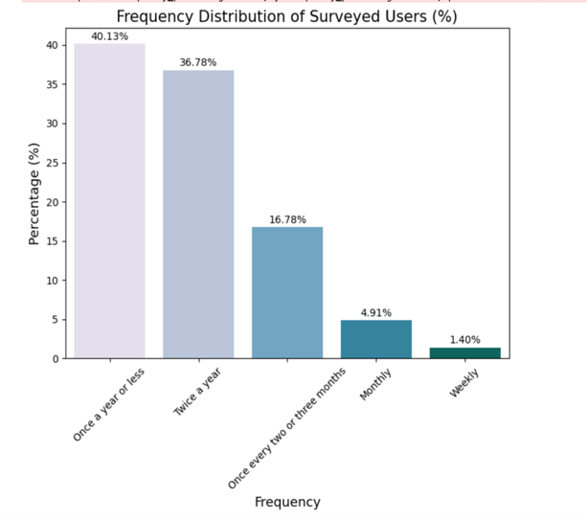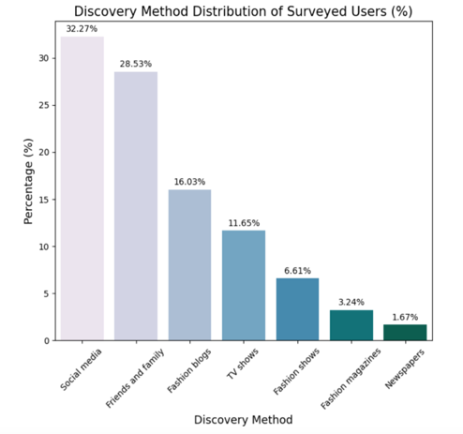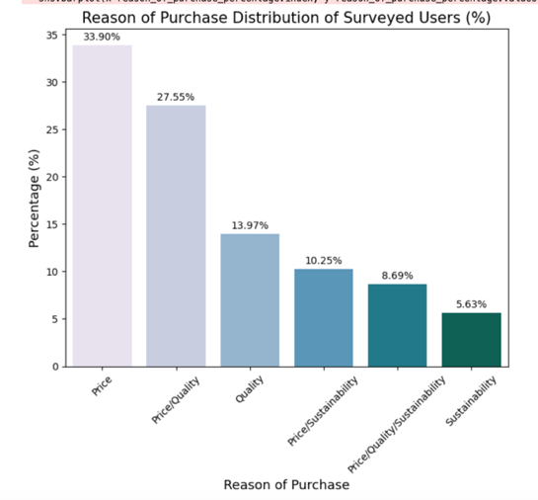

Figure 2 – Distribution of shopping venues and clothing style among surveyed users (%)

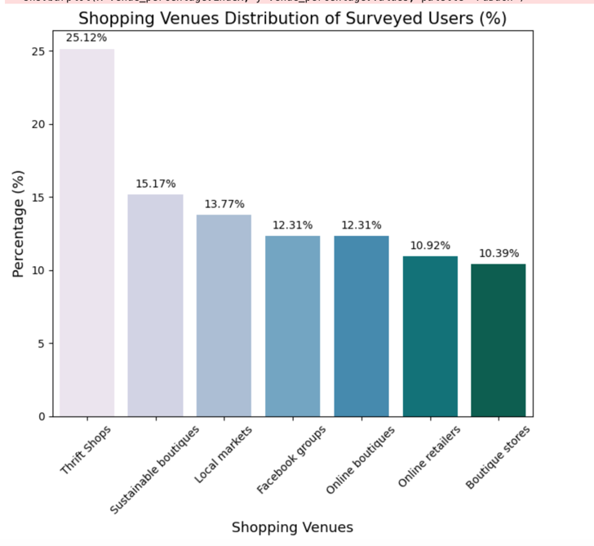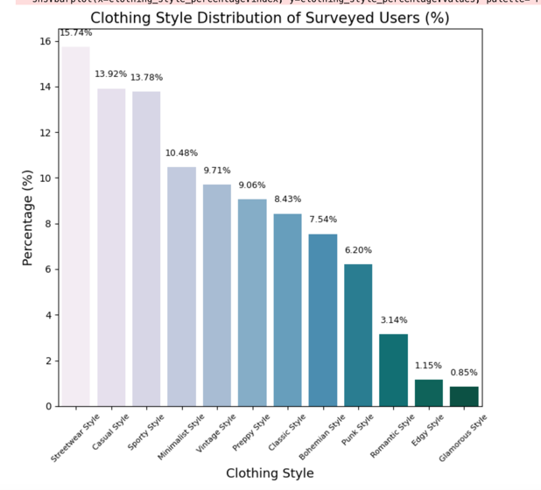

**5 RESULTS**

Cluster analysis revealed five distinct groups based on demographic, behavioral, and attitudinal variables related to sustainable fashion. These clusters reflect various consumer profiles, from younger students engaged in sustainable fashion discovery through digital means to older, retired individuals influenced by family and friends.

Cluster 1: Young Urban Trendsetters (18-24)

This group primarily consists of young female students (73.58%), with the majority residing in urban areas (82.14%). They tend to discover sustainable fashion through social media (45.83%) and purchase second-hand clothing infrequently (44.02% buy once a year or less). Price is the main motivation for their purchases (64.09%), and they are significantly influenced by sustainability labels (72.73%). Streetwear style dominates their wardrobe choices (19.58%), and thrift shops are their preferred shopping venues (36.74%). This cluster is characterized by a high impact of sustainable consumption behavior, with 69.55% acknowledging its importance.

Cluster 2: Budget-Conscious Students (25-30)

Comprised of female students (40.91%), this group is also urban-based (82.28%) and heavily influenced by social media in discovering second-hand fashion (34.40%). They tend to shop for second-hand items twice a year (53.25%) and prioritize both price and quality in their purchasing decisions (32.77%). Casual clothing is the style of choice for this cluster (17.01%). Their brand loyalty is high, with 91.75% prioritizing specific brands when shopping. Thrift shops remain a popular shopping venue (20.23%), and the influence of sustainable labels is notable (69.22%), making this group a key target for brands promoting affordability and eco-consciousness.

Cluster 3: Value-Oriented Professionals (31-40)

This cluster is composed of full-time employed females (45.47%) who rely on friends and family for fashion

discovery (35.78%). With 65.83% shopping once a year or less, they are infrequent second-hand shoppers. They emphasize both price and quality when making purchases (44.45%), and the influence of sustainable labels is prominent (84.28%). Classic clothing styles are popular in this group (20.07%). Sustainable boutiques are the preferred shopping venue for 19.76% of respondents, highlighting their interest in higher-end, eco-friendly fashion options. Their purchasing behavior is significantly impacted by sustainability considerations, with 75.05% acknowledging the importance of their actions.

Cluster 4: Practical Minimalists (41-50)

This group includes full-time employed females (61.01%) who are influenced by friends and family (43.76%) in their sustainable fashion discovery. They shop for second-hand clothing twice a year (56.03%) and prioritize price/quality (28.04%). However, only 60.14% prioritize specific brands. Minimalist styles are prevalent (19.45%), and online retailers are the preferred shopping venues (19.33%), reflecting their convenience-driven approach to second-hand fashion. Their commitment to sustainability is slightly lower compared to younger clusters, with 62.22% indicating its impact on their choices.

Cluster 5: Eco-Conscious Retirees (51-60)

The oldest cluster consists of retired females (50.70%) who discover second-hand fashion through friends and family (36.54%). They shop every two to three months (46.65%) and prioritize quality over price (36.41%). Minimalist clothing styles dominate their wardrobe (22.86%), and local markets are their preferred shopping venues (46.30%), showing a preference for community-based shopping experiences. While they exhibit slightly lower engagement with sustainability labels (64.44%), this cluster still shows a high degree of environmental consciousness, with 61.18% recognizing the impact of their fashion choices.

Figure 3 – Cluster distribution of customers

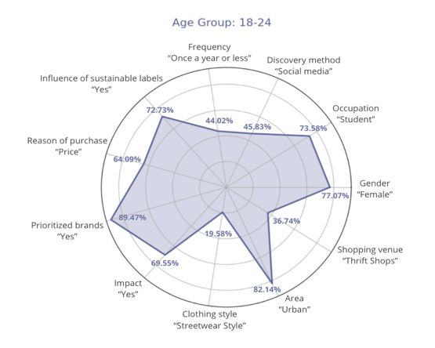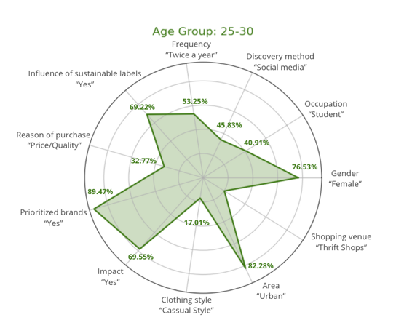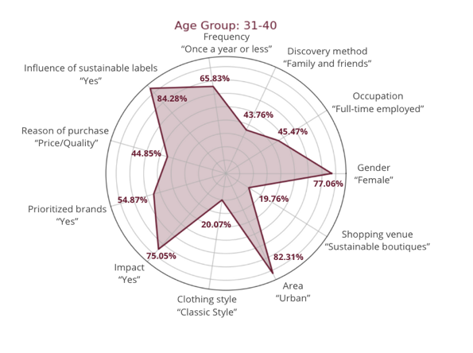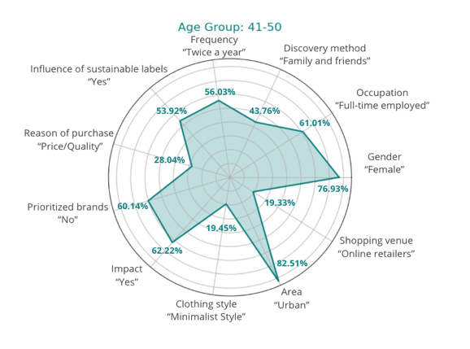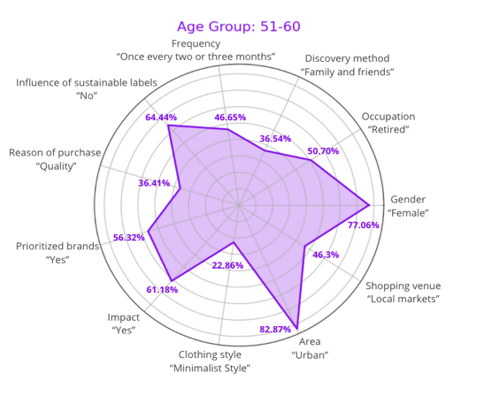

Based on the results from the cluster analysis, the formulated hypotheses were evaluated and the dominant elements that define the various consumer clusters in the second-hand clothing market were identified.

Hypothesis 1 posited that younger individuals and women are more likely to discover sustainable fashion through social media, while older consumers rely more on word of mouth or traditional media. This hypothesis is largely confirmed by the results. Cluster 1, comprised primarily of young female students, shows a strong reliance on social media for discovering second-hand fashion. On the other hand, older clusters like Cluster 3 and Cluster 5 predominantly rely on friends and family for their fashion discovery. These findings affirm that younger consumers are more digitally engaged, while older groups tend to trust personal networks.

Hypothesis 2 suggested that higher-income individuals, such as business owners and full-time employees, would purchase sustainable fashion more frequently than students or part-time workers. This hypothesis was partially confirmed. While Cluster 3, composed of full-time employed individuals, shows relatively infrequent second-hand purchases (65.83% buy once a year or less), the motivations of these consumers are more complex than income alone. The results reveal that price/quality trade-offs and the impact of sustainability labels also play significant roles in purchasing decisions, indicating that higher income does not necessarily translate into more frequent purchases of second-hand clothing.

Hypothesis 3 argued that consumers shopping online are more likely to prioritize brands with eco-friendly labels compared to those shopping in physical stores, due to the greater access to information during online shopping. This hypothesis was also partially supported. Cluster 2, which frequently shops online, does prioritize sustainable brands (69.22%). However, Cluster 4, which prefers online retailers, shows a lower engagement with sustainability labels (60.14%). Additionally, some consumers who prefer physical stores still exhibit strong eco-conscious behaviors. Thus, while online shoppers may have greater access to information, the preference for eco-friendly brands is not exclusive to online channels.

Hypothesis 4 anticipated that consumers prioritizing environmental reasons would be more likely to choose brands that promote sustainability. This hypothesis was confirmed in part. For instance, Cluster 1 and Cluster 3 demonstrate a strong influence of sustainability labels on their purchasing decisions (72.73% and 84.28%, respectively). However, not all clusters that prioritize environmental reasons consistently choose eco-friendly brands, as other factors, such as price and style, also influence their choices.

Hypothesis 5 suggested that consumers who view second-hand purchasing as a way to reduce environmental impact would exhibit a higher frequency of sustainable fashion purchases, including vintage items. This hypothesis was partially confirmed. Cluster 5, while strongly motivated by environmental concerns, does not exhibit a particularly high frequency of purchases. In contrast, Cluster 1, who also consider environmental impact, shop for second-hand clothing less frequently. These results suggest that while environmental concerns are important, other factors like personal style preferences and purchasing habits also influence the frequency of second-hand purchases.

**6 DISCUSSION**

The cluster analysis of second-hand fashion consumers yielded several key insights, confirming some of the formulated hypotheses while challenging others. These results contribute to the expanding literature on sustainable fashion consumption by providing a deeper understanding of consumer behavior and motivations in this niche market.

One of the strongest findings was the clear link between younger consumers and their reliance on social media for discovering sustainable fashion. Social platforms such as *Instagram* and *TikTok* have become key channels for promoting eco-friendly brands and vintage clothing, making them particularly appealing to the younger demographic. In contrast, older consumers, especially those outside the digital-savvy age groups, still depend more on word-of-mouth recommendations and traditional media for information. This differentiation suggests that brands targeting different age groups need to adopt distinct marketing strategies, emphasizing social media engagement for younger consumers while maintaining more traditional approaches for older segments.

While income level was initially expected to play a major role in influencing the frequency of sustainable fashion purchases, the results suggest a more complex interplay of factors. Although higher-income consumers have greater purchasing power, they are not necessarily the most frequent buyers of second-hand clothing. Instead, motivations such as ethical concerns, circular economy values, and perceived value for money emerge as equally important considerations. This indicates that consumer behavior in this market is driven not just by financial means but also by personal values and attitudes towards sustainability. These findings challenge the simplistic notion that higher-income individuals are always the most active participants in sustainable fashion markets.

Another key insight was the role of online versus physical shopping channels. While online shopping does provide more access to information, such as eco-friendly brand labels and sustainability certifications, it is not the only motivating factor for consumers prioritizing sustainable brands. Consumers shopping in brick-and-mortar stores also demonstrated a strong commitment to sustainable fashion. For many, the in-person experience, where they can see and feel the products, remains important. This highlights the ongoing relevance of physical stores, even in an increasingly digital retail environment, and suggests that sustainable brands need to maintain a balanced presence across both channels to reach a wider audience.

Environmental motivations did emerge as a significant driver for many consumers when selecting sustainable brands, but not uniformly across all segments. While some consumers consistently prioritized sustainability, others balanced their environmental concerns with practical considerations such as price, style, and availability. This complexity in decision-making points to the fact that sustainability is one of several factors influencing consumer choices, and brands need to be mindful of this balance when communicating their value propositions. Simply focusing on environmental credentials may not be enough to sway all consumers, particularly those who are more price-sensitive or style-driven.

Finally, the relationship between environmental consciousness and purchase frequency was nuanced. Although consumers with strong environmental motivations were more likely to view second-hand purchasing as a way to reduce their ecological footprint, not all exhibited high purchase frequencies. In some cases, environmentally conscious consumers may engage in more deliberate, less frequent shopping, consistent with sustainable consumption practices that emphasize quality over quantity. These findings suggest that while sustainability plays a role in shaping purchasing behavior, it does not necessarily correlate with higher volumes of consumption, particularly among those who are mindful of minimizing waste.

**CONCLUSIONS**

As environmental concerns rise and awareness of the damaging effects of fast fashion grows, more consumers are turning to second-hand clothing as a responsible and conscious choice. Through cluster analysis, this study has revealed distinct consumer groups who prioritize sustainability, affordability, and ethical consumption in their purchasing decisions.

The formulated hypotheses were partially confirmed, revealing a more nuanced understanding of consumer behavior:

Hypothesis 1 anticipated younger individuals would rely on digital channels, and older consumers would prefer traditional methods for discovering sustainable fashion. This was confirmed, with younger clusters like Young Urban Trendsetters (Cluster 1) heavily using social media, while older consumers (Clusters 3 and 5) relied on personal networks.

Hypothesis 2 posited that higher-income individuals would shop more frequently, but the results indicated that factors like price-quality balance and sustainability labels also significantly influence purchasing decisions. For example, Value-Oriented Professionals (Cluster 3), while having higher incomes, were infrequent shoppers.

Hypothesis 3 suggested online shoppers would prioritize eco-friendly brands more, yet the results showed varying degrees of engagement across both online and offline consumers.

Hypothesis 4, predicting a stronger preference for sustainable brands among environmentally motivated shoppers, was partially supported. Clusters such as Young Urban Trendsetters (Cluster 1) and Value-Oriented Professionals (Cluster 3) displayed high regard for sustainability labels.

Hypothesis 5 proposed that higher environmental consciousness would lead to more frequent sustainable purchases, yet some highly eco-conscious groups, like Eco-Conscious Retirees (Cluster 5), shopped less frequently.

The importance of sustainable clothing extends beyond individual choices; it reflects a broader shift in societal values toward reducing waste, conserving resources, and embracing circular economy principles. By identifying the motivations and behaviors of second-hand clothing consumers, this research emphasizes how the industry can contribute to environmental protection by reducing textile waste and the overall carbon footprint of fashion production.

Businesses in the fashion industry must recognize these emerging consumer segments and respond with strategies that promote sustainability, from offering more second-hand options to incorporating eco-friendly practices into their supply chains. Sustainable fashion is not just a trend but a necessary response to global environmental challenges. As the industry continues to evolve, second-hand clothing offers a viable solution that benefits both consumers and the planet.

Future research should delve deeper into the long-term impact of sustainable fashion choices on global consumption patterns and investigate how companies can further promote eco-friendly fashion on a larger scale. Sustainable clothing, especially in the second-hand market, holds the key to a more responsible, ethical, and environmentally friendly future for fashion.

**ACKNOWLEDGEMENTS**

The work is supported by the state budget scientific research project of State University of Trade and Economics “Development of Data Science tools” (state registration number - 0122U001548). Supervisor: A. A. Roskladka, Doctor of Economics, professor, head of the Department of Digital Economy and System Analysis.

**REFERENCES**

1. The impact of textile production and waste on the environment (infographics) | Topics | European Parliament. *Topics | European Parliament*. URL: <https://www.europarl.europa.eu/topics/en/article/20201208STO93327/the-impact-of-textile-production-and-waste-on-the-environment-infographics>
2. Diddi S., Yan R.-N. Consumer Perceptions Related to Clothing Repair and Community Mending Events: A Circular Economy Perspective. *Sustainability*. 2019. Vol. 11, no. 19. P. 5306. URL: <https://doi.org/10.3390/su11195306>
3. Brandão A., Costa A. G. d. Extending the theory of planned behaviour to understand the effects of barriers towards sustainable fashion consumption. *European Business Review*. 2021. Vol. 33, no. 5. P. 742–774. URL: <https://doi.org/10.1108/ebr-11-2020-0306>
4. Guiot D., Roux D. A Second-hand Shoppers’ Motivation Scale: Antecedents, Consequences, and Implications for Retailers. *Journal of Retailing*. 2010. Vol. 86, no. 4. P. 355–371. URL: <https://doi.org/10.1016/j.jretai.2010.08.002>
5. Ek Styvén M., Mariani M. M. Understanding the intention to buy secondhand clothing on sharing economy platforms: The influence of sustainability, distance from the consumption system, and economic motivations. *Psychology & Marketing*. 2020. Vol. 37, no. 5. P. 724–739. URL: <https://doi.org/10.1002/mar.21334>
6. YARAN ÖGEL İ. Is it sustainability or fashion? Young educated consumers’ motivations for buying second-hand clothing. *Business & Management Studies: An International Journal*. 2022. Vol. 10, no. 3. P. 817–834. URL: <https://doi.org/10.15295/bmij.v10i3.2064>
7. Consumer orientations of second-hand clothing shoppers / M. Zaman et al. *Journal of Global Fashion Marketing*. 2019. Vol. 10, no. 2. P. 163–176. URL: <https://doi.org/10.1080/20932685.2019.1576060>
8. Gwozdz, W., Steensen Nielsen, K. and Müller, T. An environmental perspective on clothing consumption: Consumer segments and their behavioral patterns. *Sustainability*. 2017. [e-journal] 9(5). <https://doi.org/10.3390/su9050762>.
9. Tabianan K., Velu S., Ravi V. K-Means Clustering Approach for Intelligent Customer Segmentation Using Customer Purchase Behavior Data. *Sustainability*. 2022. Vol. 14, no. 12. P. 7243. URL: <https://doi.org/10.3390/su14127243>
10. John J. M., Shobayo O., Ogunleye B. An Exploration of Clustering Algorithms for Customer Segmentation in the UK Retail Market. *Analytics*. 2023. Vol. 2, no. 4. P. 809–823. URL: <https://doi.org/10.3390/analytics2040042>
11. Customer Segmentation Analysis Using Clustering Algorithms / B. S. V. Reddy et al. *Intelligent Systems*. Singapore, 2023. P. 353–368. URL: <https://doi.org/10.1007/978-981-99-3932-9_31>
12. de Vries N. J., Olech Ł. P., Moscato P. Introducing Clustering with a Focus in Marketing and Consumer Analysis. *Business and Consumer Analytics: New Ideas*. Cham, 2019. P. 165–212. URL: <https://doi.org/10.1007/978-3-030-06222-4_3>
13. Solomon M. R., Rabolt N. J. Consumer Behavior: In Fashion. Prentice Hall, 2003. 542 p.
14. Barnes L., Lea‐Greenwood G. Fast fashioning the supply chain: shaping the research agenda. *Journal of Fashion Marketing and Management: An International Journal*. 2006. Vol. 10, no. 3. P. 259–271. URL: <https://doi.org/10.1108/13612020610679259>
15. Carrigan M., Attalla A. The myth of the ethical consumer – do ethics matter in purchase behaviour?. *Journal of Consumer Marketing*. 2001. Vol. 18, no. 7. P. 560–578. URL: <https://doi.org/10.1108/07363760110410263>
16. Rausch T. M., Kopplin C. S. Bridge the gap: Consumers’ purchase intention and behavior regarding sustainable clothing. *Journal of Cleaner Production*. 2021. Vol. 278. P. 123882. URL: <https://doi.org/10.1016/j.jclepro.2020.123882>
17. Farrant L., Olsen S. I., Wangel A. Environmental benefits from reusing clothes. *The International Journal of Life Cycle Assessment*. 2010. Vol. 15, no. 7. P. 726–736. URL: <https://doi.org/10.1007/s11367-010-0197-y>
18. K-Means Clustering- Introduction. *Analytics Vidhya*. URL: <https://www.analyticsvidhya.com/blog/2019/08/comprehensive-guide-k-means-clustering/>
19. Understanding Inertia and Silhouette Coefficient - Key Metrics in Clustering Analysis. *Continuous Improvement*. URL: <https://victorleungtw.com/2023/12/16/inertia/>

УДК 334.75

**СЕГМЕНТАЦІЯ СПОЖИВАЧІВ ВИКОРИСТОВУЮЧИ ІНСТРУМЕНТИ КЛАСТЕРНОГО АНАЛІЗУ ДЛЯ ВИВЧЕННЯ ОСНОВНОЇ ТЕНДЕНЦІЇ НЕДОСПОЖИВАННЯ**

**Субботін С. О.** – к.т.н., доц. Проф., кафедра цифрової економіки та системного аналізу, Державний торговельно-економічний університет, Київ, Україна.

**Щербина Ю. О.** – бакалавр кафедри інформаційних технологій, Державний торговельно-економічний університет, м. Київ, Україна.

**AНОТАЦІЯ**

**Актуальність.** Індустрія моди дедалі більше зміщується в бік сталого розвитку, а ринок вживаного одягу відіграє ключову роль у просуванні циклічної практики моди. Концепція « underconsumption core» наголошує на уважному споживанні, зосереджуючись на якості, а не на кількості.

**Мета роботи** – проаналізувати поведінку споживачів у промисловості вживаного одягу. Використовуючи методи кластерного аналізу, визначити окремі сегменти споживачів на основі їх мотивації та купівельної поведінки.

**Метод.** Пропонується комплексний підхід для оцінки поведінки споживачів щодо сталої моди, зосереджуючись на демографічних і соціально-економічних факторах. Цей підхід використовує кластерний аналіз для визначення окремих сегментів у наборі даних, використовуючи кластеризацію k-mean як основну техніку. K-means було обрано через його ефективність і результативність у розділенні даних на значущі кластери, що дозволяє легко інтерпретувати профілі споживачів на основі їх купівельної поведінки. Процес кластеризації починається з визначення оптимальної кількості кластерів, що досягається за допомогою методу Elbow. Цей метод є перевагою, оскільки він забезпечує чітке візуальне представлення показників інерції, сприяючи прийняттю обґрунтованих рішень щодо кількості кластерів, які потрібно сформувати, мінімізуючи при цьому можливість переобладнання. Етап попередньої обробки даних включає нормалізацію відповідних характеристик для забезпечення однорідності та порівнянності в різних масштабах. Цей крок є критично важливим, оскільки запобігає непропорційному впливу будь-якої однієї змінної на результати кластеризації. Після цього виконується алгоритм k-means, який ітеративно уточнює центроїди кластерів, доки не буде досягнуто конвергенції, таким чином мінімізуючи відстані між кластерами та максимізуючи відстані між кластерами. Це ітераційне уточнення гарантує, що отримані кластери є надійними та відображають справжні сегменти споживачів. Крім того, метод включає графічні візуалізації для ілюстрації розподілу відповідей у ​​різних демографічних сегментах. Ці візуальні інструменти були обрані через їх здатність представляти складні дані в доступному форматі, покращуючи інтерпретацію.

**Результати.** Розроблені показники реалізовано в програмному забезпеченні та досліджено для вирішення проблем сегментації споживачів у стійкій індустрії моди. Результатом аналізу стали чіткі кластери, які ефективно диференціюють цільову аудиторію, надаючи цінну інформацію про поведінку та вподобання споживачів. Ці кластери виявляють суттєві закономірності, пов’язані з віком, професією та місцем проживання, що дозволяє використовувати цільові маркетингові стратегії, які відповідають цінностям сталого розвитку різних сегментів споживачів.

**Висновки.** Сучасний бізнес процвітає, надаючи високоперсоналізовані послуги своїм клієнтам, що було б неможливо без певної форми сегментації клієнтів. Роблячи це, організації можуть легко структурувати свої послуги та продукти навколо своїх клієнтів, орієнтуючись на них, щоб збільшити дохід. Проведені експерименти підтвердили функціональність впровадженого програмного забезпечення, продемонструвавши його ефективність у вирішенні проблем сегментації клієнтів у стійкий спосіб. Отримані дані підтверджують рекомендацію цього програмного забезпечення для практичного використання для діагностики та автоматичної класифікації профілів споживачів на основі конкретних ознак. Перспективи майбутніх досліджень включають розробку паралельних методів для розрахунку запропонованих індикаторів, оптимізацію їх реалізації програмного забезпечення та проведення експериментальних досліджень для застосування цих індикаторів до більш складних практичних проблем у різних контекстах і вимірах.

**КЛЮЧОВІ СЛОВА:** сталість, сегментація, поведінка споживачів, underconsumption core, кластерний аналіз, python, візуалізація даних.

**ЛІТЕРАТУРА**

1. The impact of textile production and waste on the environment (infographics) | Topics | European Parliament. *Topics | European Parliament*. URL: <https://www.europarl.europa.eu/topics/en/article/20201208STO93327/the-impact-of-textile-production-and-waste-on-the-environment-infographics>
2. Diddi S., Yan R.-N. Consumer Perceptions Related to Clothing Repair and Community Mending Events: A Circular Economy Perspective. *Sustainability*. 2019. Vol. 11, no. 19. P. 5306. URL: <https://doi.org/10.3390/su11195306>
3. Brandão A., Costa A. G. d. Extending the theory of planned behaviour to understand the effects of barriers towards sustainable fashion consumption. *European Business Review*. 2021. Vol. 33, no. 5. P. 742–774. URL: <https://doi.org/10.1108/ebr-11-2020-0306>
4. Guiot D., Roux D. A Second-hand Shoppers’ Motivation Scale: Antecedents, Consequences, and Implications for Retailers. *Journal of Retailing*. 2010. Vol. 86, no. 4. P. 355–371. URL: <https://doi.org/10.1016/j.jretai.2010.08.002>
5. Ek Styvén M., Mariani M. M. Understanding the intention to buy secondhand clothing on sharing economy platforms: The influence of sustainability, distance from the consumption system, and economic motivations. *Psychology & Marketing*. 2020. Vol. 37, no. 5. P. 724–739. URL: <https://doi.org/10.1002/mar.21334>
6. YARAN ÖGEL İ. Is it sustainability or fashion? Young educated consumers’ motivations for buying second-hand clothing. *Business & Management Studies: An International Journal*. 2022. Vol. 10, no. 3. P. 817–834. URL: <https://doi.org/10.15295/bmij.v10i3.2064>
7. Consumer orientations of second-hand clothing shoppers / M. Zaman et al. *Journal of Global Fashion Marketing*. 2019. Vol. 10, no. 2. P. 163–176. URL: <https://doi.org/10.1080/20932685.2019.1576060>
8. Gwozdz, W., Steensen Nielsen, K. and Müller, T. An environmental perspective on clothing consumption: Consumer segments and their behavioral patterns. *Sustainability*. 2017. [e-journal] 9(5). <https://doi.org/10.3390/su9050762>.
9. Tabianan K., Velu S., Ravi V. K-Means Clustering Approach for Intelligent Customer Segmentation Using Customer Purchase Behavior Data. *Sustainability*. 2022. Vol. 14, no. 12. P. 7243. URL: <https://doi.org/10.3390/su14127243>
10. John J. M., Shobayo O., Ogunleye B. An Exploration of Clustering Algorithms for Customer Segmentation in the UK Retail Market. *Analytics*. 2023. Vol. 2, no. 4. P. 809–823. URL: <https://doi.org/10.3390/analytics2040042>
11. Customer Segmentation Analysis Using Clustering Algorithms / B. S. V. Reddy et al. *Intelligent Systems*. Singapore, 2023. P. 353–368. URL: <https://doi.org/10.1007/978-981-99-3932-9_31>
12. de Vries N. J., Olech Ł. P., Moscato P. Introducing Clustering with a Focus in Marketing and Consumer Analysis. *Business and Consumer Analytics: New Ideas*. Cham, 2019. P. 165–212. URL: <https://doi.org/10.1007/978-3-030-06222-4_3>
13. Solomon M. R., Rabolt N. J. Consumer Behavior: In Fashion. Prentice Hall, 2003. 542 p.
14. Barnes L., Lea‐Greenwood G. Fast fashioning the supply chain: shaping the research agenda. *Journal of Fashion Marketing and Management: An International Journal*. 2006. Vol. 10, no. 3. P. 259–271. URL: <https://doi.org/10.1108/13612020610679259>
15. Carrigan M., Attalla A. The myth of the ethical consumer – do ethics matter in purchase behaviour?. *Journal of Consumer Marketing*. 2001. Vol. 18, no. 7. P. 560–578. URL: <https://doi.org/10.1108/07363760110410263>
16. Rausch T. M., Kopplin C. S. Bridge the gap: Consumers’ purchase intention and behavior regarding sustainable clothing. *Journal of Cleaner Production*. 2021. Vol. 278. P. 123882. URL: <https://doi.org/10.1016/j.jclepro.2020.123882>
17. Farrant L., Olsen S. I., Wangel A. Environmental benefits from reusing clothes. *The International Journal of Life Cycle Assessment*. 2010. Vol. 15, no. 7. P. 726–736. URL: <https://doi.org/10.1007/s11367-010-0197-y>
18. K-Means Clustering- Introduction. *Analytics Vidhya*. URL: <https://www.analyticsvidhya.com/blog/2019/08/comprehensive-guide-k-means-clustering/>
19. Understanding Inertia and Silhouette Coefficient - Key Metrics in Clustering Analysis. *Continuous Improvement*. URL: <https://victorleungtw.com/2023/12/16/inertia/>